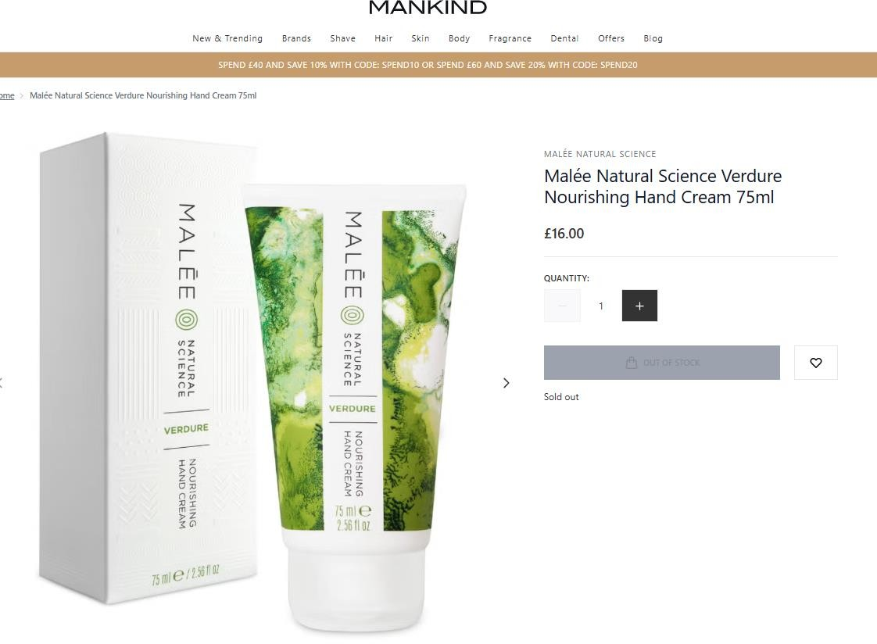

1,473pcs x Malee Natural Science Verdure Nourishing Hand Cream 75ml……..RRP £16

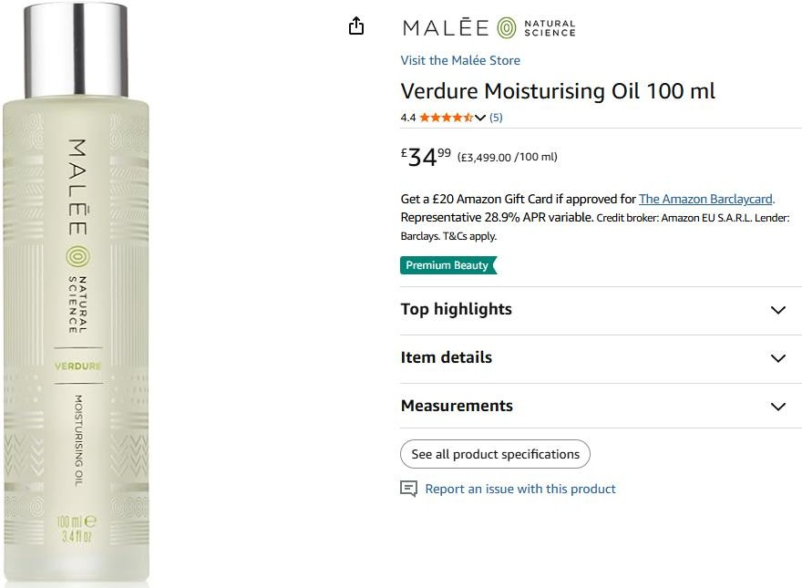

1,470pcs x Malee Verdure Moisturising Oil 100ml………Selling on amazon for £34.99

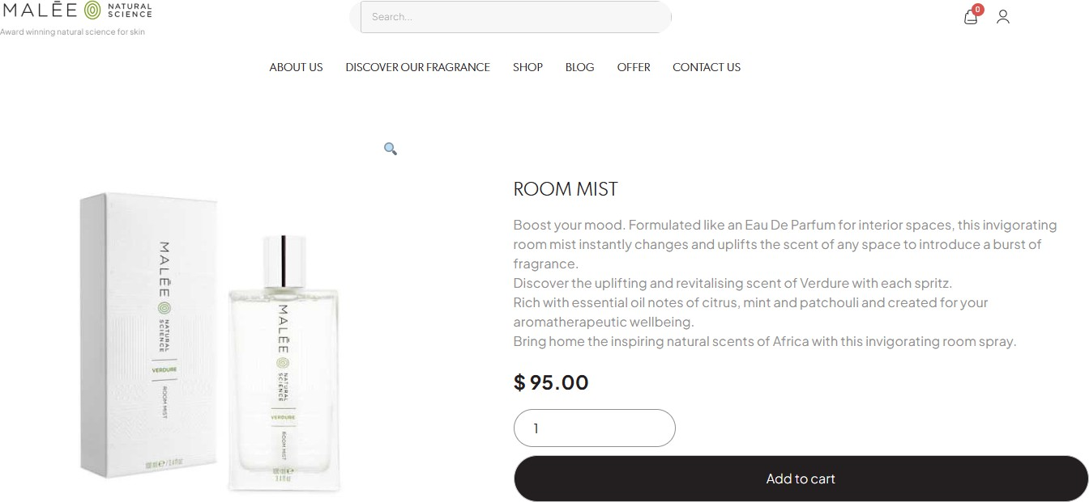

2,479pcs x Malee Room Mist 100ml………RRP $95

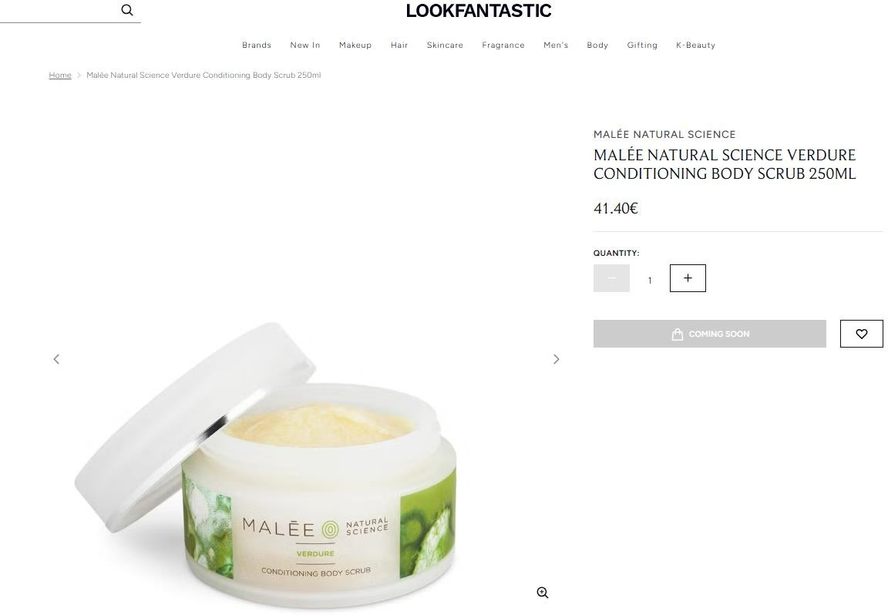

2,365pcs x Malee Natural Science Verdure Conditioning Body Scrub 250ml………RRP 41.40 Euros

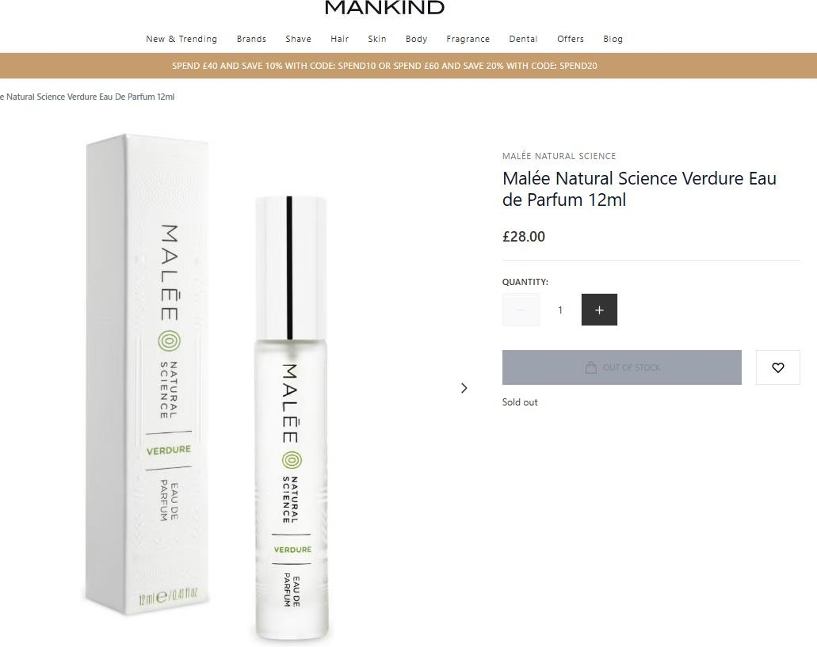

2,446pcs x Malee Natural Science Verdure EDP 12ml……….RRP £28

